“It’s a real benefit for our community have someone like Dr. Thorne here. I’ve experienced firsthand teh type of care he provides and now I recommend him and his team to all of my athletes adn their parents.”
-Coach Mark Holt Orthopaedic Patient

For An Appointment
Call: 812.254.2663 (BONE)

No appointment necessary for high school
or college athlete injuries.

Hours:
Monday-Thursday 8 am to 4 pm Fridays 8 am to noon
Orthopaedics & Sports Medicine
Let our team of Orthopaedic specialists provide you a comprehensive range of care, surgical repair, and digital imaging in one convenient location.

412 E Van Trees, Washington IN 47501

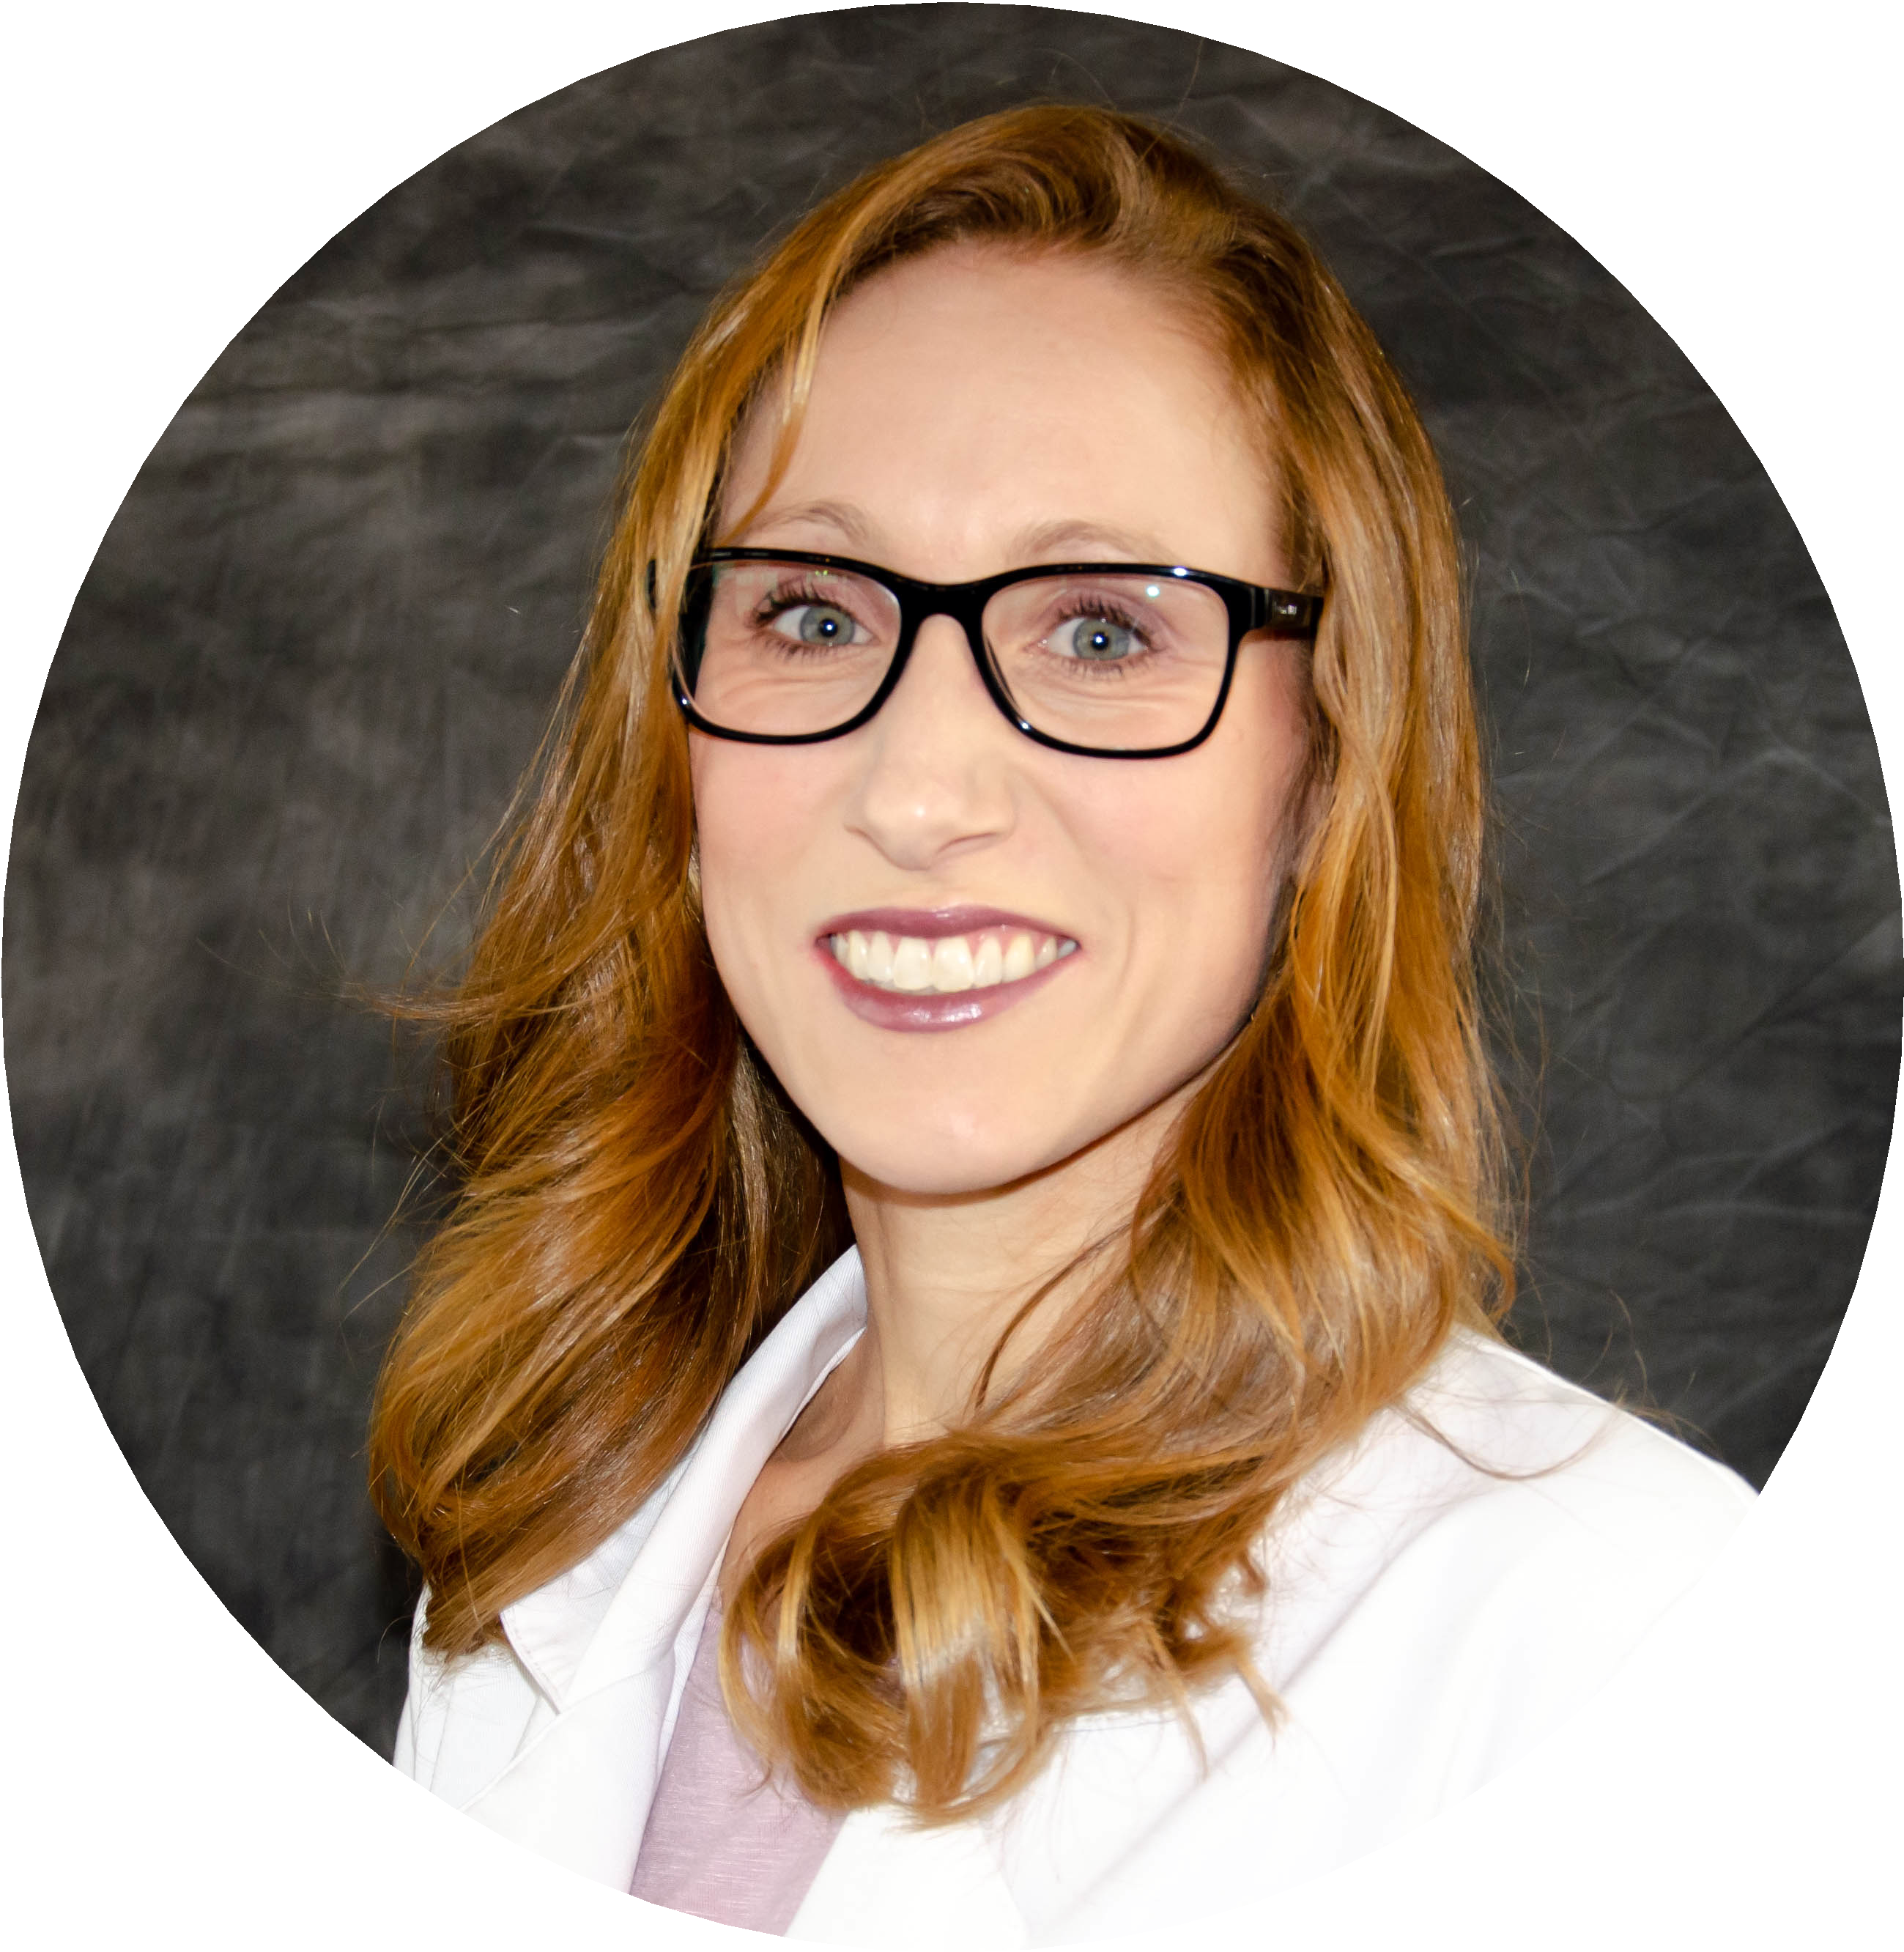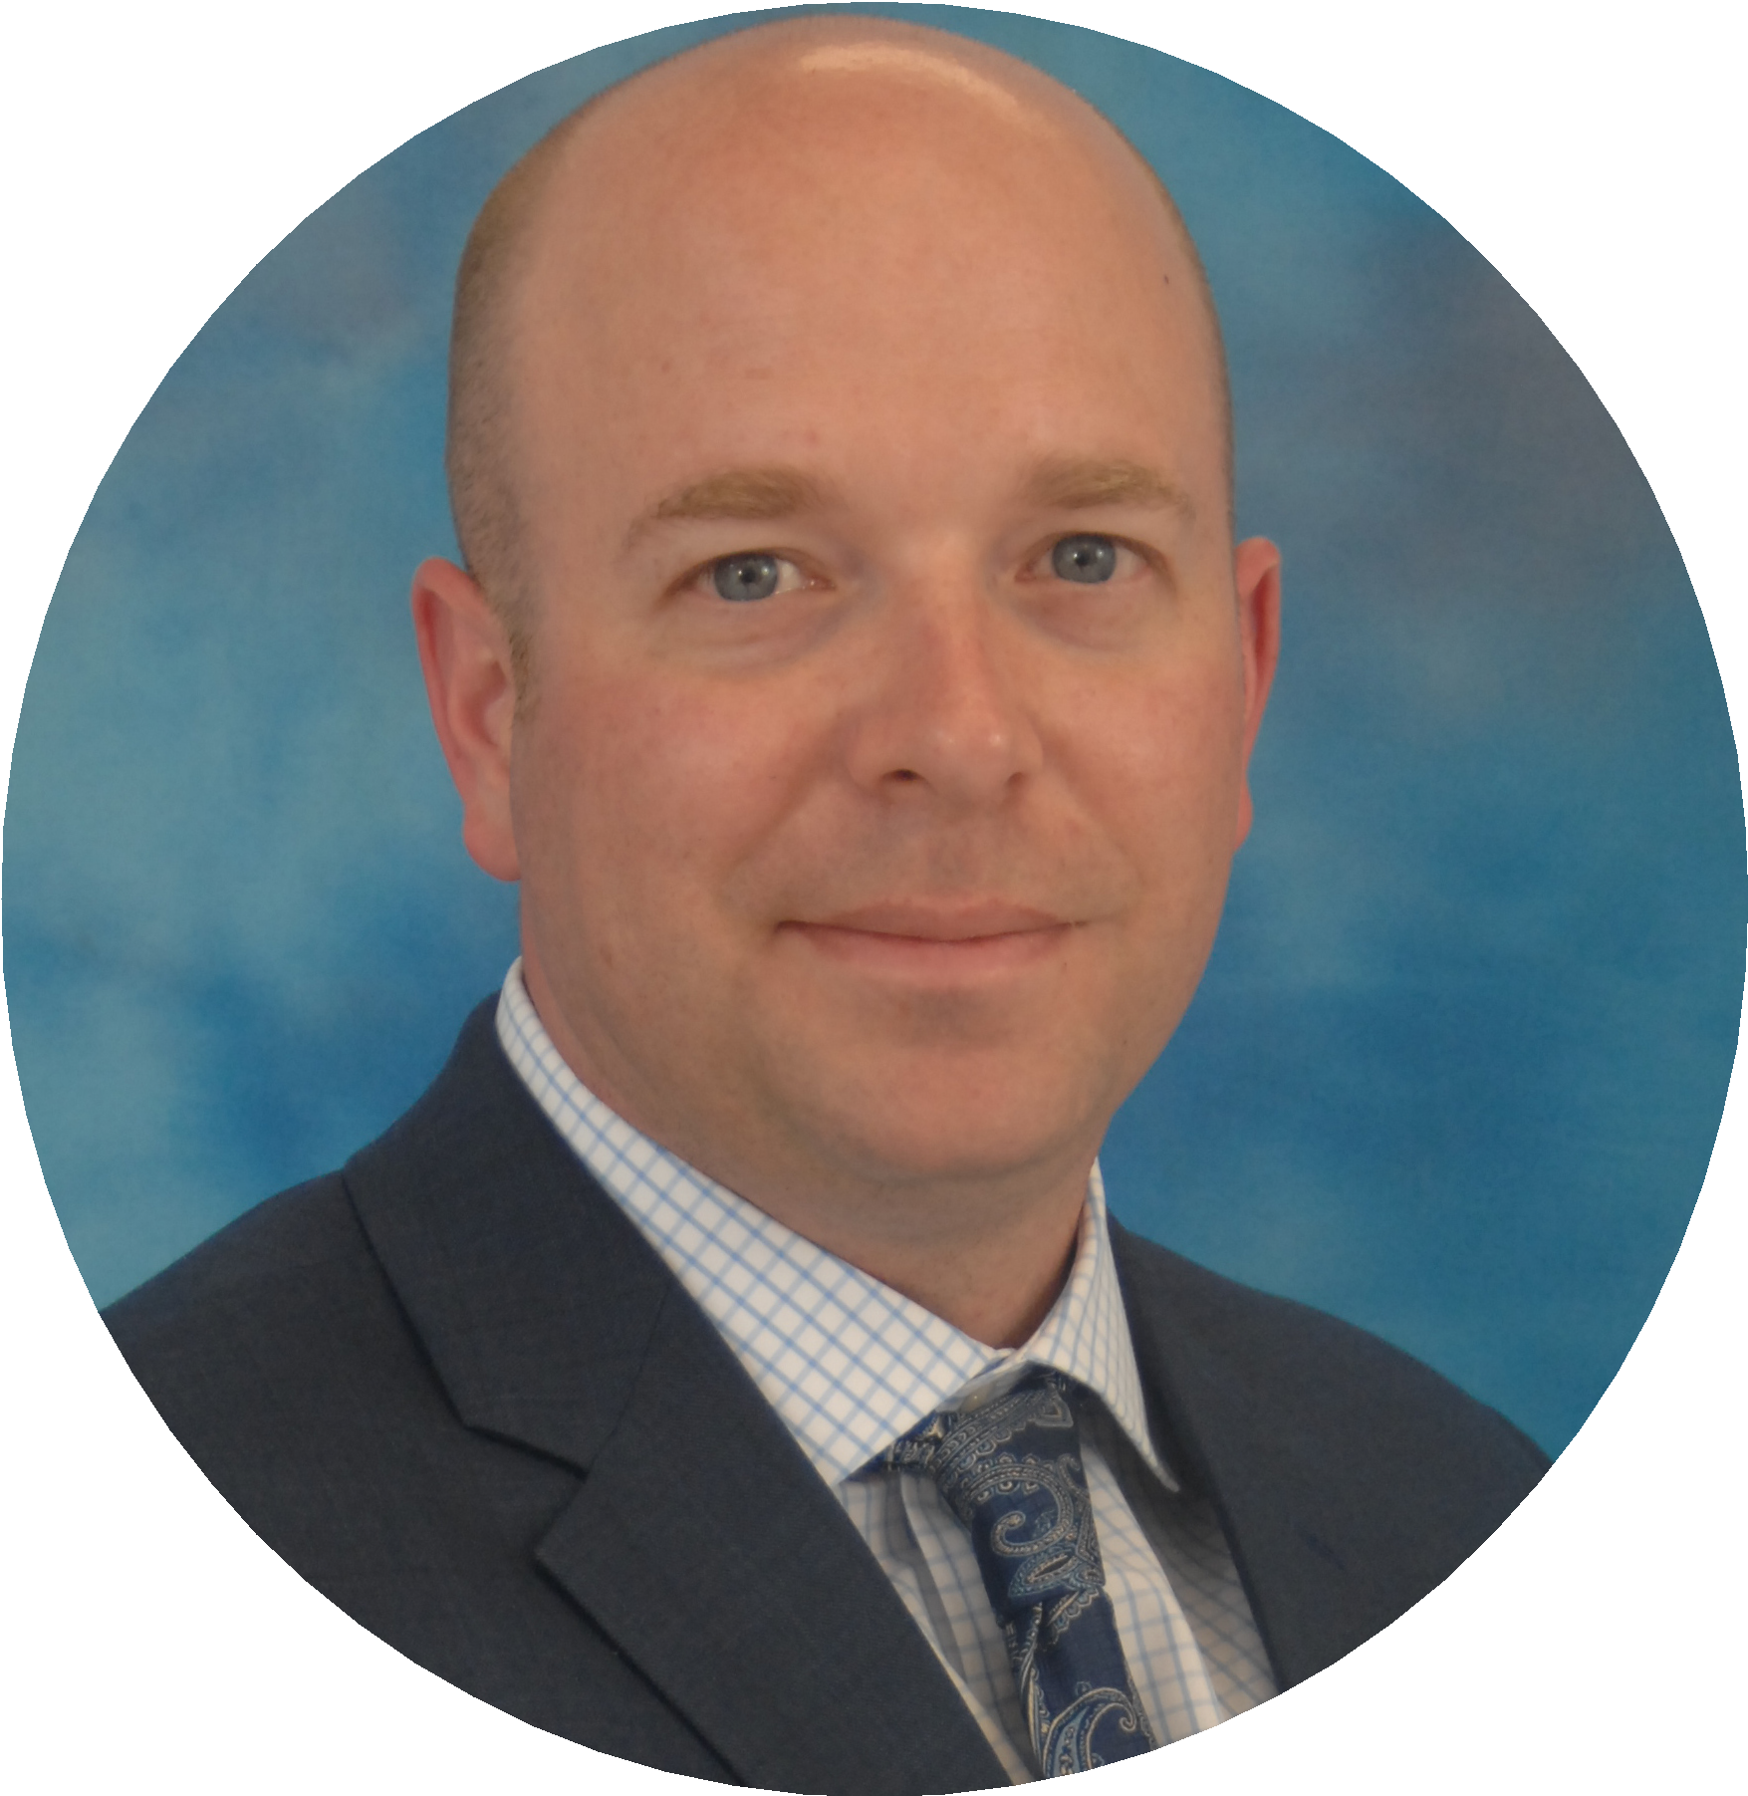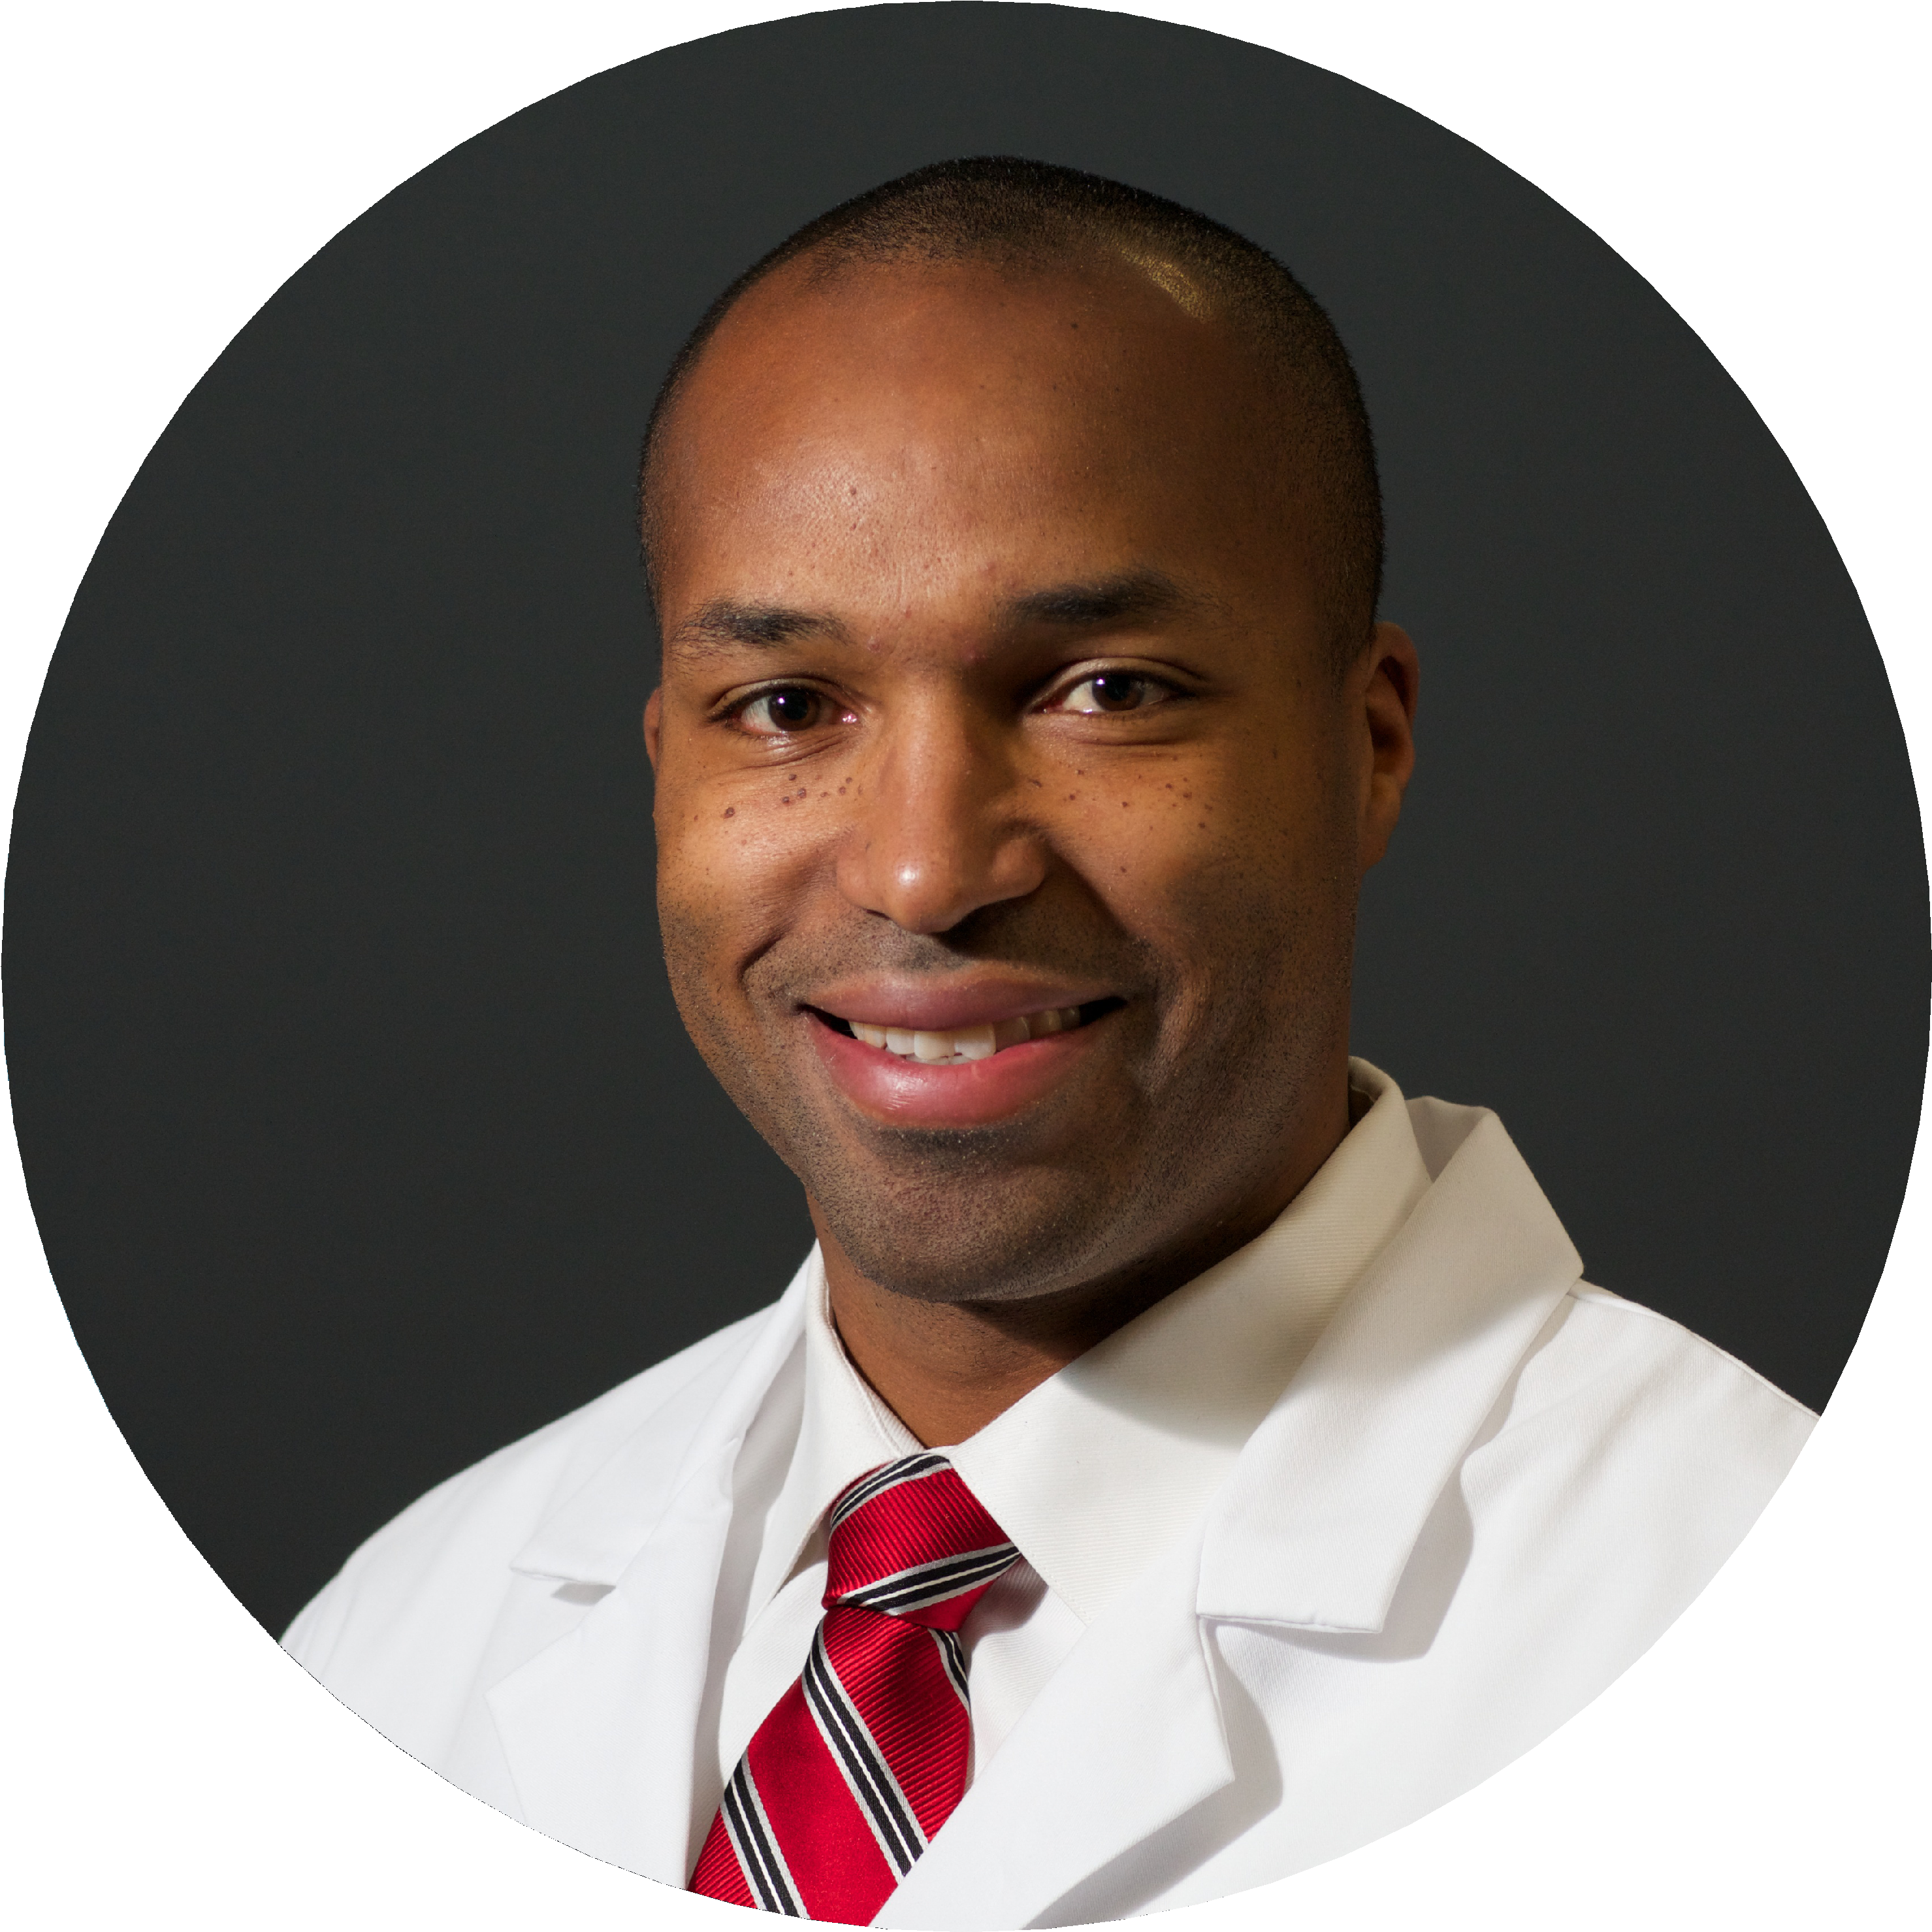
Our Providers
Dr. Marcus Thorne
Board-certified orthopaedic surgeon; American Academy of Orthopaedic Surgeons; and the Notre Dame Orthopaedic Society
Andrew Houchins, PA-C US Air Force Fellowship trained Orthopaedic Surgery PA;
Retired US Air Force (2018, Major)
Allison Krieger, FNP
Board-certified Nurse Practioner American Academy of Nurse Practitioners

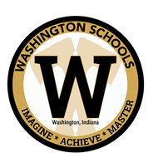
DCH Orthopaedics is the exclusive provider of athletic training services for the following student athletes and sports teams:

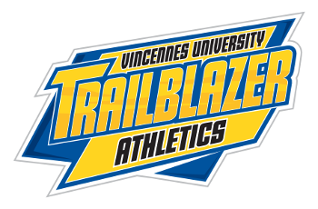
Our Services

Our team of Orthopaedic specialists offer patients a comprehensive range of care, surgical repair, and digital imaging all in one convenient location.
Treatment for orthopaedic conditions may include medication, exercise, physical therapy or surgery. We strive to prescribe minimally invasive treatments whenever possible, and may recommend mere exercise or physical therapy in order to help you restore movement and function. Once your acute care is finished, our team will also instruct you on preventive care measures you can take to avoid future injury.

- Treatment of ankle sprains, fractures and instability.
- Treatment of rotator cuff impingement, labral tears, shoulder dislocation and shoulder arthritis.
- Treatment of hand fractures and dislocations, sprains, strains, and muscle or ligament tears, injuries to tendons, nerves, or vessels, and numbness or weakness in the hand or arm (including carpal tunnel syndrome).
- Treatment for arthritis, contractures, swelling or inflammation of the joints.
- Knee ligament and meniscus injuries
- Treatment of tennis elbow, neuritis, and tendonitis.
- Fractures and sports injuries.
- Reverse shoulder surgery.
- Hip Replacement surgery.
- Knee Replacement surgery.

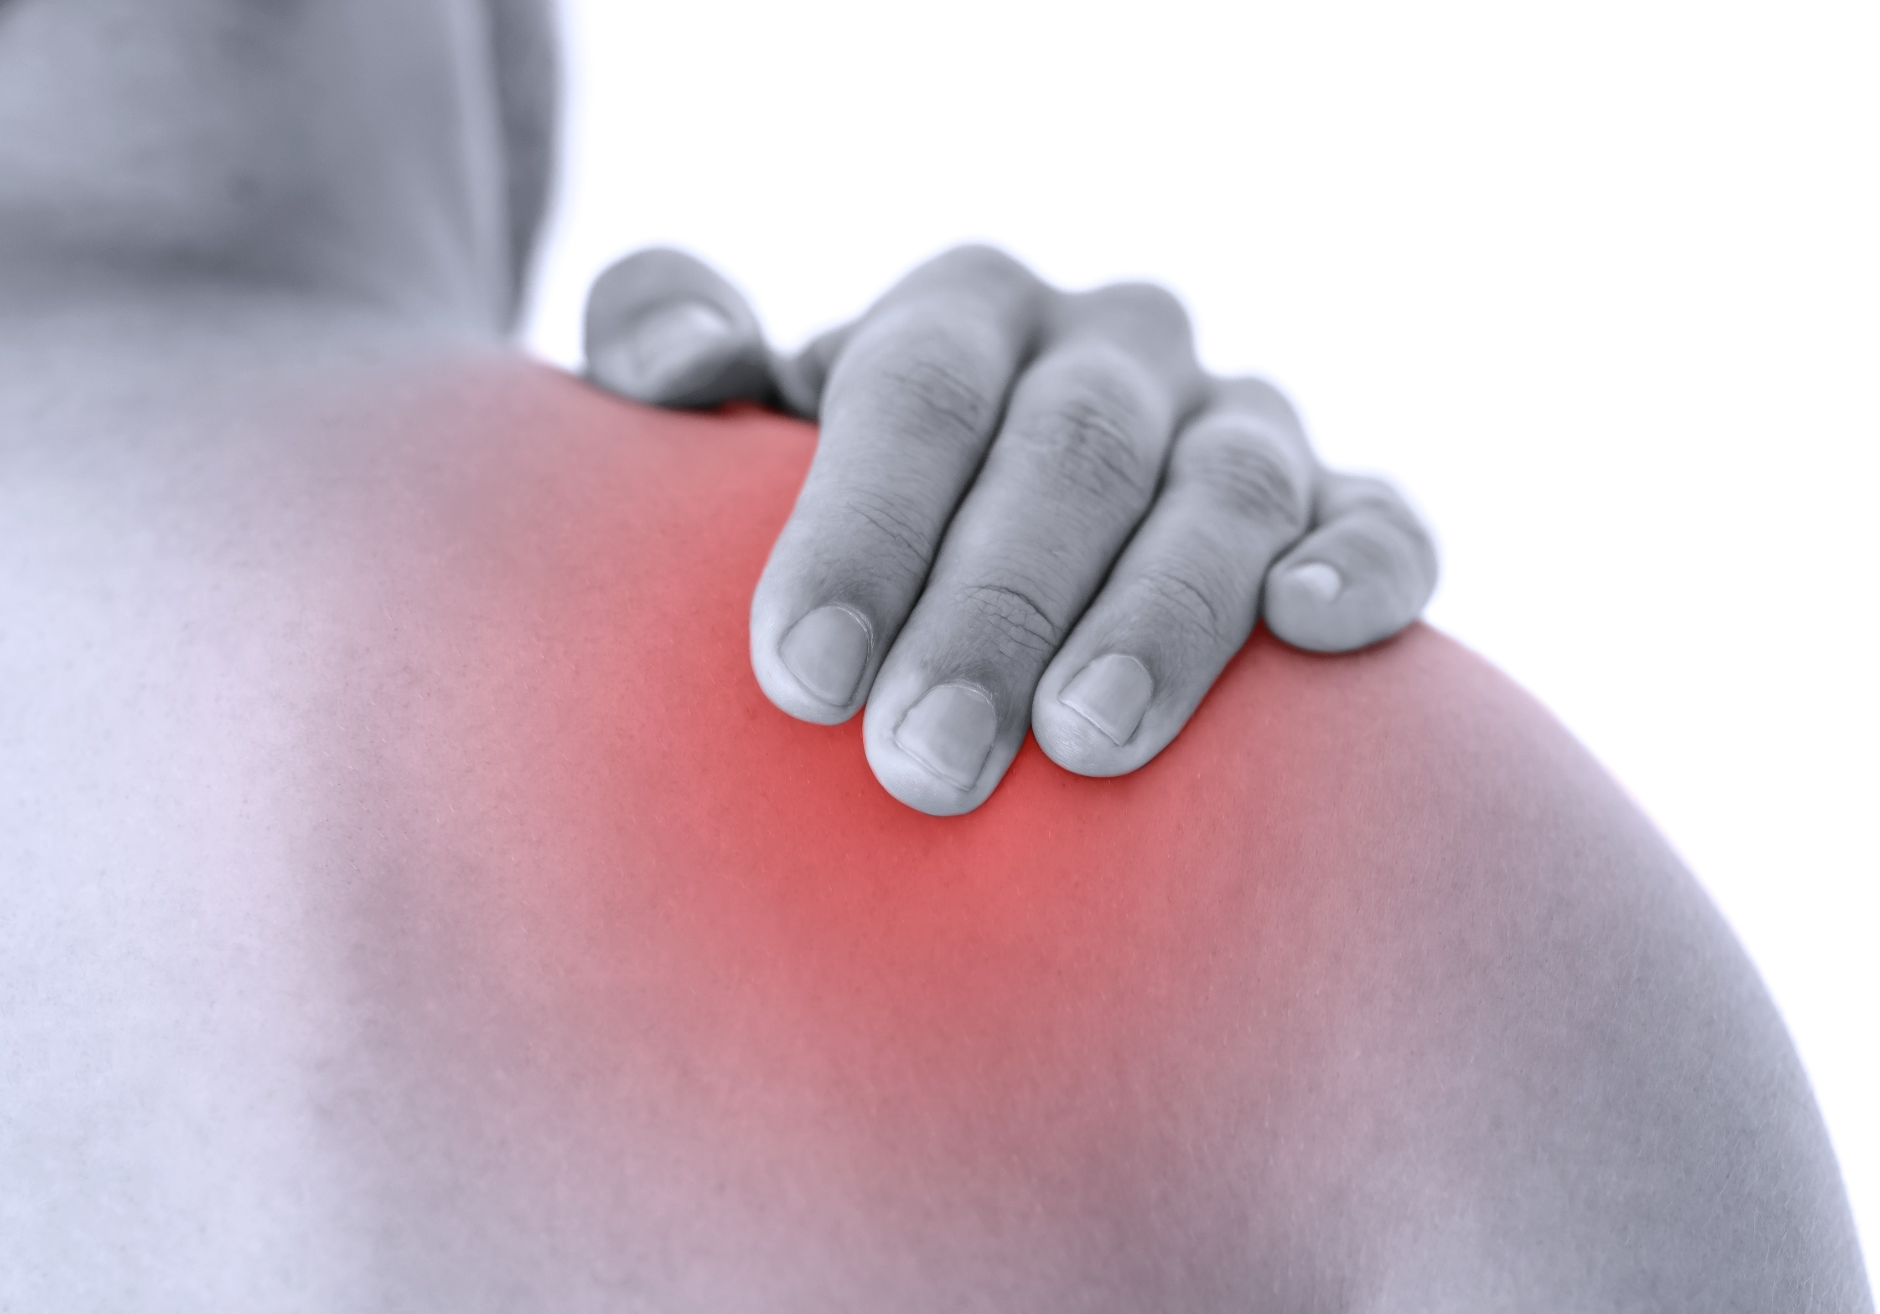Suffering from knee, shoulder or other joint pain?
Focused on sports medicine, total joint
replacement, fracture care, and arthroscopy of the knee and shoulder.
The DCH Orthopaedic team offers Platelet rich plasma (PRP) injections. This all natural option is used for a variety of common orthopaedic conditions.

PRP is a concentration of platelet cells taken from your blood. These platelets have growth factors that may help in the healing process of chronic injuries.
PRP injections can be done in the provider’s office. The procedure takes about 30 minutes.
Natural Injections to heal damage and reduce inflammation

