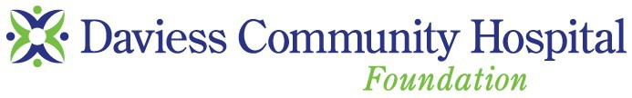Please print this form, fill in and mail to the address below:

Give the Gift of Health

by supporting

PLEDGE FORM

1314 East Walnut Street Washington, Indiana 47501
(812) 254-2760, ext. 1126

Daviess Community Hospital Foundation
Whether small or large, your gift will make a difference in the lives
of those receiving services through Daviess Community Hospital.

DONOR INFORMATION:
Name: Check here if you wish to remain ANONYMOUS.

Mailing Address:

City:
State:
Zip:

Phone Number:
Email:

GIFT PLEDGE AMOUNT: $
Please use where there is “Greatest Need” Designate for:

PAYMENT METHOD:
This pledge will be paid over a period of years, beginning with my first gift on .

Please send reminders: annually on
semi-annually on

quarterly on
monthly on

Please make checks payable to: Daviess Community Hospital Foundation.

Credit Card: All major credit cards accepted.

Credit Card Number: Exp Date:

Cardholder Name:

Signature:

MY GIFT IS (please print):

In Memory of:

In Honor of:

PLEASE SEND ACKNOWLEDGEMENT TO:

Name:

Mailing Address:

City:
State:
Zip:

ABOUT DAVIESS COMMUNITY HOSPITAL FOUNDATION:
Daviess Community Hospital Foundation is a not-for-profit 501( c)(3) organization. All gifts are tax deductible as allowed by law. Please consult your financial advisor.
“Community is our middle name.”

